Img Filename: 0000172.jpg

CTW Raw Image:

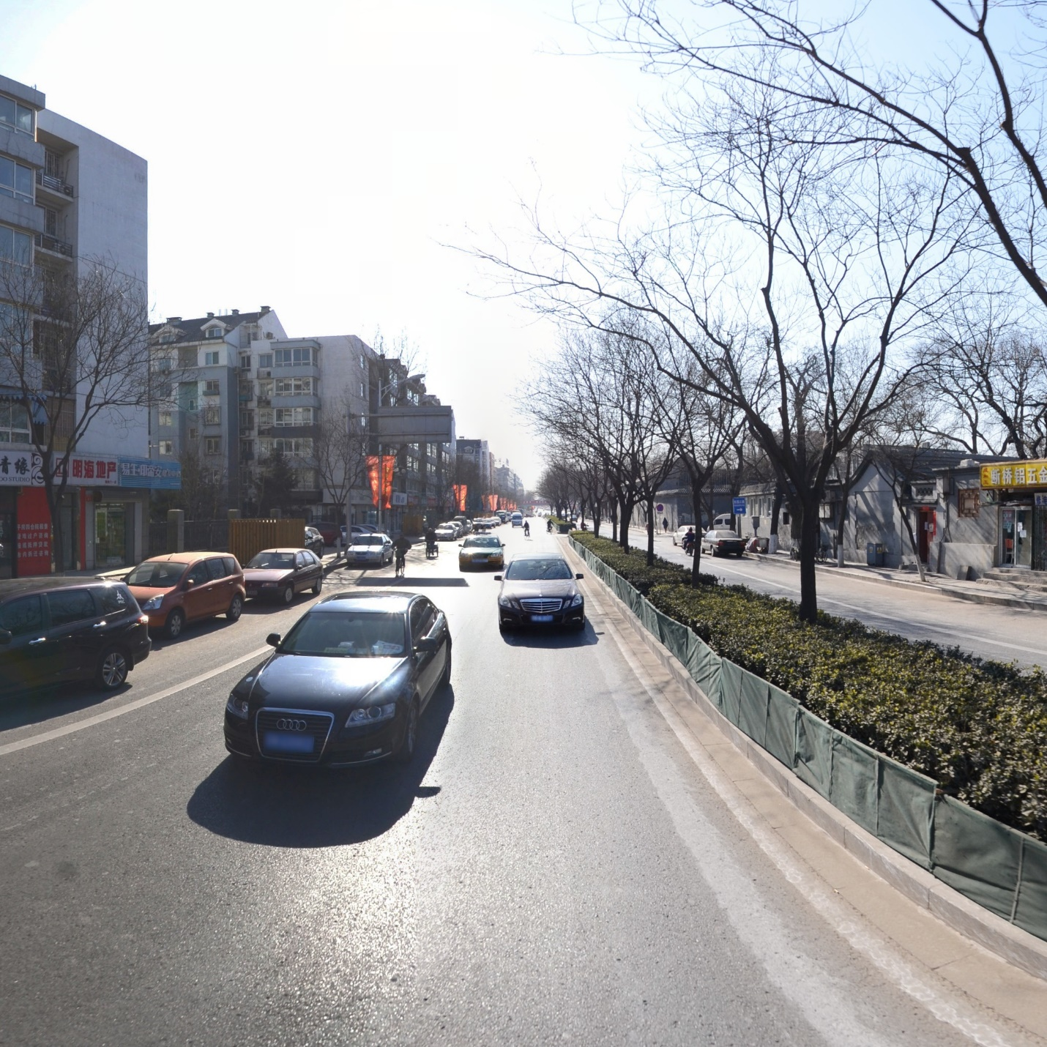

Label Bounding box with Annotation jsonl:

